**Contents**

* Introduction………………………………….………………………………... 1
  + - About Company ...………………………………………..…………. 2
    - Products and Customers ...…………………………………………. 3
    - Departmental Division……………………………………................ 4
    - Job Description………………………………………………………. 5
* Process Flow…………………………………………………………………. 6
* Product Flow………………………………………………………………….. 6
* Product Manufacturing Flow………………………………………………… 6
  + - New Development……………………………………………………. 7
      * + Replacement Parts…………………………….…………….. 8
        + Original Equipment’s Parts………………………………….. 9
* Customer Handling…………………………………………………………... 10
  + - Engineering Change Notes…………………………………………. 11
    - Field Failure……………………………………………………………12
    - Customer Audits/ Process Audits…………………………………... 13
* Audits………………………………………………………………………….. 14
  + - IATF Audit…………………………………………………………….. 15
    - OHSAS Audit…………………………………………………………. 16
    - Internal Audits………………………………………………………... 17
* Conclusion……………………………………………………………………..18

**1. Introduction**

* Introduction to company
* Group Mission
* Products Manufactured
* Types of Gears
* Spur
* Helical
* Double Helical
* Bevel Gears
* Rack and Pinions
* Worm Gear
* Our Customers
* Tool Room Facility
* CTD Facility
* Financial Analysis
* Departmental Division
* Job Description

**The Introduction to Company:**

The Gajra Group made its beginnings in 1950 with the formation of Elve Corporation. Originally trading in diesel engines and spares it then moved on to making Gears in 1962 with the setup of Gajra Gears. After establishing a name in automotive gears the group further added to its capabilities by setting up Gajra Differential Gears in 1991.

Currently Gajra Gears is the largest manufacturer of automobile transmission gears in India boasting a strength of over 1000 trained and committed employees and offering a range of around 1700 gears for virtually every major brand of truck, car, jeep, and tractor.

Keeping pace with the gear industry's ever evolving needs Gajra Gears over the years has further extended its capabilities to cater to railway, off road and other niche segments of gear application.

Although initially concentrating on the Indian aftermarket, today more than 50% of the products manufactured at Gajra Gears are exported across the globe.

With a modest beginning the group has over the years expanded its product range. The Gajra Group now offers transmission and differential gears, cutting tools and tooling’s (jigs, fixtures) that serve the purpose of manufacturing these gears, material handling pallets for the safe movement of these goods and machined castings and assemblies.

What drives this growth at Gajra is commitment to top quality by following good manufacturing practices and providing outstanding customer service:

* Strong Brand Image
* Latest Technology Machines
* Strong Product Development & Reverse Engineering

Capabilities

* 50% of Revenues from Exports
* Over 25% annual growth in OEM business
* In house cutting tool & fixture mfg.
* Over 45+ years’ experience in gear mfg.
* Highly skilled manpower
* Over 1000 products variety mfg.
* Exports mainly in DIN 6-8 class.
* Continuous training & improvement
* Supplier Upgradation - ISO-9000.

**Introduction**

* Best Manufacturing Practices - Six Sigma, TPM, TQM.
* IAFT-2015 certification
* Well-equipped R&D facility with advanced designing software.
* Precise CMM machine for part inspection.

**Group Mission:**

To transcend to new heights of being recognized as a World Class Gear Manufacturer across the globe. This can be achieved by producing superior quality products in minimum delivery times through the use of latest machine tools, application of best manufacturing practices and adherence to stringent quality standards. Gajra believes in total customer satisfaction through open communication, quality up-gradation and continuous training, the practice of which will lead it to being recognized as a World Class Gear Manufacturer.

**Products Manufactured:**

Gajra Gear is a gear manufacturing company which deals in transmission as well as differential gear manufacturing. Before we move we must be clear about what is a gear and why is it used for?

A gear is a rotating circular machine part having cut teeth or, in the case of a cogwheel or gearwheel, inserted teeth (called cogs), which mesh with another (compatible) toothed part to transmit (convert) torque and speed. The basic principle behind the operation of gears is analogous to the basic principle of levers. A gear may also be known informally as a cog. Geared devices can change the speed, torque, and direction of a power source. Gears of different sizes produce a change in torque, creating a mechanical advantage, through their gear ratio, and thus may be considered a simple machine. The rotational speeds, and the torques, of two meshing gears differ in proportion to their diameters. The teeth on the two meshing gears all have the same shape.

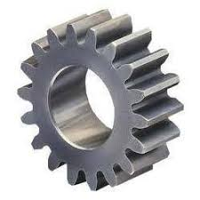Two or more meshing gears, working in a sequence, are called a gear train or a **transmission**. The gears in a transmission are analogous to the wheels in a crossed, belt pulley system. An advantage of gears is that the teeth of a gear prevent slippage. In transmissions with multiple gear ratios—such as bicycles, motorcycles, and cars—the term "gear" (e.g., "first gear") refers to a gear ratio rather than an actual physical gear. The term describes similar devices, even when the gear ratio is continuous rather than discrete, or when the device does not actually contain gears, as in a CVT. Sometimes a CVT is referred to as an "infinitely variable transmission"

Image showing Simple Spur Gear

**Types of Gears:**

**Introduction**

Depending upon the power, torque axis alignment gears are divide into different categories. Gears can be classified in various types according to construction of teeth, Use, the direction of motion transfer etc. but basically it is classified according to design of teeth. But here we will be discussing by point of manufacturing. The following are the types of gear as per manufacturing view:

**1. Spur Gear:**

These gears are used to transmit the power in same plane or when the driving and driven shafts are parallel to each other. In this type of gear teeth are cut parallel to the axis of the shafts so when is meshes with another spur gear it transmit the power in parallel shaft and when it connects with the helical gear it will transmit power at an angle from the driving axis.

**2. Helical Gear:**

On the helical gears teeth are cut at an angle from the axis of it. It has cylindrical roller with helicoid teeth. The main advantage of helical gears is that they work with less noise and vibration because the load is distributed on the full helix as compared to spur gears. It also has less wear and tear due to which they are widely used in industries. It also used for transmit power in parallel shaft but sometime they are used to transmit power in non-parallel shaft also. In the helical gears if the pinion (driving gear) is cut with right handed teeth then the gear (driven gear) is cut with left handed of in opposite direction.

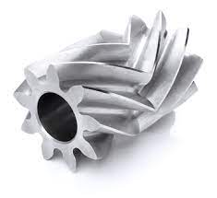

**3. Double Helical or Herringbone Gear:**

This gear has both right and left handed teeth on one gear. This gear is use to provide additional shear area on gear which further required for higher torque transmission. This is same as helical.

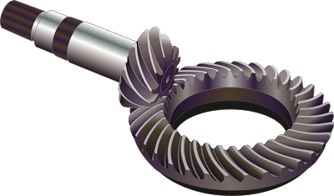**4. Bevel Gear:**

This gear is used to transmit power between perpendiculars. The driving shaft and driven shaft makes a right angle with each other and both the axis of shaft meets each other at one point. This gear has helical or spiral teeth on a conical shaped geometry and meshes with the same gear.

**5. Rack and Pinion Gear:**

This gear is used in steering system of automobile. In this type of gear, teeth are cut on a straight rectilinear geometry know as rack and one spur gear known as pinion. This is used to transmit rotary motion to linear motion. It is seen as the infinite radius driven gear.

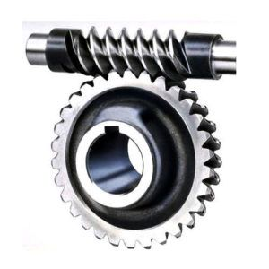**6. Worm Gear:**

This type of gear is used to transmit the power in nonintersecting shaft which makes right angle. In this type of arrangement the driving gear is a screw gear and the driven gear is helical gear or gear with spiral teeth as shown in figure.

**Customers:**

**Introduction**

The company is serving to its domestic as well as international customers in Original Equipment (O.E.) and replacement parts. Gajra has developed many new customer through the journey and yet the journey is going on. The company has successfully satisfied customer in Agricultural machinery, agriculture vehicles, public transport vehicle etc. The list is very long but here are the few customer listed

**1. Force Motors:**

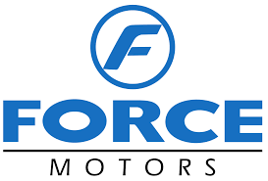Force Motors Ltd, is an Indian multinational automotive manufacturing company, based in Pune, India and the flagship company of the Dr. Abhay Firodia Group. From 1958 until 2005, the company was known as Bajaj Tempo Motors because it originated as a joint venture between Bachraj Trading Ltd. and Germany's Tempo.

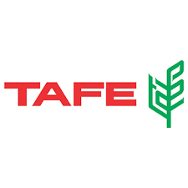**2. TAFE:**

Tractors and Farm Equipment Limited, is an Indian agricultural machinery manufacturer based in Chennai, India. TAFE is the third-largest tractor manufacturer in the world and the second largest in India by volume.

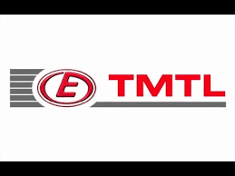**3. TMTL:**

TMTL Engines Division is a unit of TAFE Motors and Tractors Limited (TMTL) with Alwar, Rajasthan, India, as its manufacturing base. TMTL is a wholly owned subsidiary of Tractors and Farm Equipment Limited (TAFE)

**4. KRONE:**

Maschinenfabrik Bernard Krone GmbH is one of Europe's foremost producers of forage wagons, self-loading forage wagons, disc mowers, rotary tedders, rakes, and large square balers, round balers, forage harvesters and high-performance mower conditioners. The company is present in many countries including the USA

**5. KESSLER:**

Kessler is a leading manufacturer of various engineering products such as drive train, power, energy, agricultural equipment’s and machinery etc.

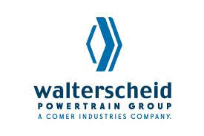**6. WALTESCHIED:**

GKN Ltd is a British multinational automotive and aerospace components business headquartered in Redditch, England. It is a long-running business known for many decades as Guest, Keen and Nettlefolds.

**7. VOITH TURBO:**

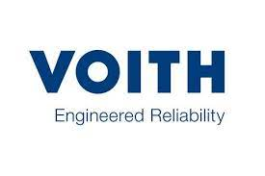Voith’s operating business is bundled in three Group Divisions: Voith Hydro, Voith Paper, and Voith Turbo.A large proportion of the world’s paper production is manufactured on Voith paper machines. A quarter of the energy generated worldwide from hydropower is produced with turbines and generators from Voith Hydro. Voith’s drive components are found in applications all over the world, both in industrial plants and in road and rail vehicles, as well as on the waters.

**The Tool Room Facility:**

**Introduction**

Gajra Gear is a gear manufacturing company which has its own tool room. It’s a great advantage to have the tool room of our own. This facilitated the Gajra to produce the tooling in house and deliver then in time as per the requirement. The tool room also produces for the outer customer too. Many special gauges and tooling which are not able to be produced in small vendors are produced here in Gajra Gear’s Tool Room.

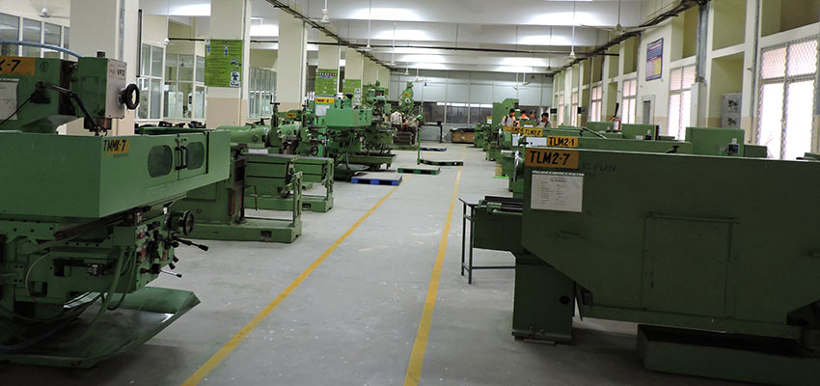

**The Cutting-Tool Division Facility (CTD):**

Gajra Gear is a gear manufacturing company which is equipped with in house cutting tool manufacturing facility and re-sharpening facility. Since the cutting tool manufacturing takes a lot of time in manufacturing hence Gajra has developed its own cutting tool division to cut the lead time in gear manufacturing. This facility not only produces the cutting tools for in house items but also for the other customers too. Cutting tools such as Hob, Milling cutter, shaper cutter, broaches etc., are manufactures here.

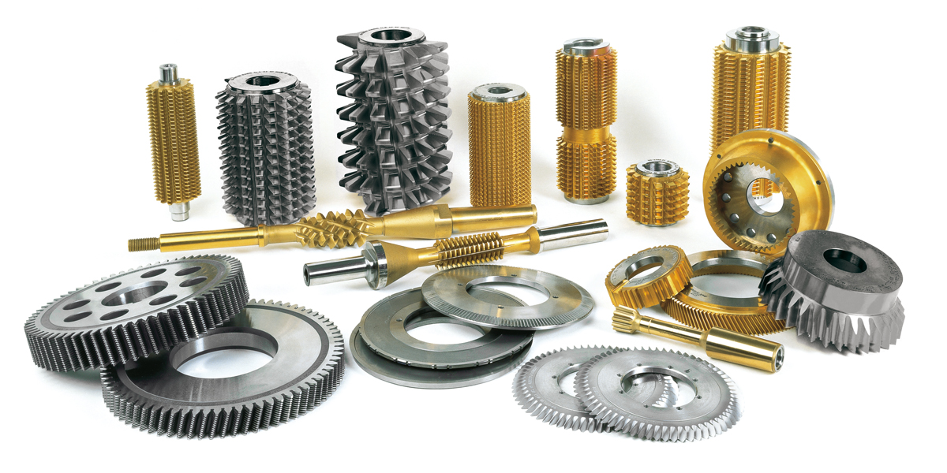

**Targets Analysis:**

**Introduction**

The overall target

**Departmental Division:**

**Introduction**

A department is a part of a larger organization and can be organized around a number of different parameters such as function. The term ‘department’ can refer to a number of different things. For example, an administrative division within a nation, a governmental ministry or even a part of an institution.

In larger companies, departments might have the ability to act more autonomously, making decisions that benefit their department directly with the intent that they’ll have a positive impact on the entirety of the organization.

Smaller companies might be more interactive and function together, making more collective decisions that are considered for their overall impact before action is taken.

For smaller companies, departments may not be as useful, but each company has their own individual needs and should decide as they see fit.

In this particular definition, we refer to the term ‘department’ as it’s used to refer to separate divisions of an organization.

Gajra Gear also used departmental system for improved efficiency. The flow chart below shows the various departments in the organization

**Flow chart showing the Simple Department Division Structure**

**Department Allotted (Research & Development):**

I was allotted Research and Development Department which look after the development activity of the product and engineering implementation. The R&D is the mother of the products developed in the company, this department deals with all the respective department effectively. Marketing, purchase production are all moved as per the decision of the R&D. All the Engineering functions are evaluated and analyzed in this department this department is the treasure of Manuals original product drawings and a lots of samples. The department is has its own predefined objective and SOP defined for each and every work, many work instructions are made, many formats are present depending upon the use. The department consist of 35+ members which have preassigned tasks and roles. They all works as a team and try to get the maximum of the resources applied or input. The R&D keeps the account of the products developed and under development, RFQ received and the components developed. It look after the running and the productionized components.

The department deals with many responsibilities such as:

**Introduction**

* Manufacturing Route Decision.
* Costing and Feasibility Study of Parts.
* Sample development of new RFQ’s
* PPAP lot Development
* Production handover of Successful Parts.
* Cutting Tool, Gauges, Fixture Designing
* Forging Designing. Packing Designing, Material handling.
* Manufacturing Standard’s Audits, Engineering Standard’s Audits, Customer Audits

And many More

**Flow Chart Showing the Basic Departmental Structure**

**Job Responsibility Allotted:**

I am assigned the role of Senior Engineer along with group leading. I use to look after the new development activity of the component Route decision, Layout Preparation, Cutting tooling and jig & Fixture designing and to prepare documentation (PPAP APQP etc.) Major responsibility is to clear the various audits held such as customer’s process audits, IATF audit OHSAS audits, internal audits and various other audits.

**2. Process Flow**

**What is a Process?**

* What is Process
* What is Process Flow
* Process Flow at Gajra
* Product Flow
* Product Manufacture Flow
* New Product Development
* O.E. Parts Flow
* Replacement Parts Flow

The series of actions, motions, or operations leading to some result is termed as a process. If the series is lead to manufacturing of products then it is said as manufacturing process and if it is defined in terms of computer operation then it is termed as system process. Any how the systematic way of getting the output from the inputs is Process. It involves many stages to accomplish the output from input these stages togather are called as a process.

**What is Process Flow?**

A process flow diagram is a diagram commonly used in chemical and process engineering to indicate the general flow of plant processes and equipment. The PFD displays the relationship between major equipment of a plant facility and does not show minor details such as piping details and designations.

A business process flow is a sequential representation of a process and its components, including operations, timelines, and people involved, and resources needed. The main objective of process flows is to help you standardize and optimize your processes and help your team better understand how your business works.

The process flow can be easily understand using the graphical method of representation which is called process flow diagram (PFD).

**Process Flow at Gajra:**

Since Gajra is a Gear manufacturing company and hence a product based company and the product based company has a great importance of the process carried out. Processes in the industry are the value addition to the raw material. Each and every process which is applied on the raw material adds some values for final product. There are various machines, material and man power required to process the gear. Machines like CNC turning, Hobbing machine, Shaping machine, Milling machine, Shaving machine etc. are of great importance. The persons working here have their own importance and contribution in the product. They enhance the product by the beauty of engineering in gear manufacturing, we will be understanding the process in Gajra in two parts:

1. Product Flow
2. Manufacturing Flow

**Product Flow:**

**Process Flow**

`The product flow will show us how the product is taken in consideration or how the product reaches the Gajra manufacturing facility. The process starts from the marketing department and continues till the end user get satisfied. The process flow diagram below will help to easily understand the process.

**A Flow Chart Showing the General Flow of Components**

The process starts from marketing department: the marketing peoples researches the market and target the customer in this case customer are the machine or vehicle manufacturers where gears are required for power transmission. The marketers represent the company and try to get the orders for RFQ. The customers provide the marketing representative with the product drawing or sample and in care of Replacement parts sample is provided along with annual quantity and ask for the quotation.

The marketing team then supply the Product drawing or the sample in case of replacement part to the Research and Development Department for the engineering study and manufacturing study. The R&D allots **R Number** (R-XXXX) to the parts and RFQ registration is done for further tracking the component. Here the RFQ team looks each and every point of the drawing and identifies that weather the noted standards, quality, dimensional capacity are able to produce in the existing plant facility. They thoroughly study the drawing and in case of sample each and every point is examined for producing, here in case of sample received from customer reverse engineering is performed, the process of making the product from its sample is called Reverse Engineering. The RFQ team calculates forging weight and finished weigh of the part and create a Route sheet. This route sheet consist of systematic listing of various operations to be carried out and various list of tooling (Cutting tools, gauges, and fixtures). The route sheet also consists of the approximate price of the cutting tools. All the special process or any outsource requirement is identified and noted. Any previously made component (if any) is also referred in study.

This Routine sheet is then forwarded to Production Planning Control Department (PPC) for the capacity and planning evaluation. The PPC person here calculate the MHR (Machine Hour Rate) and the time required in completing the operation. PPC also study the capacity that weather we are able to produce the capacity required in the current manufacturing facility or we require some machinery or other things. PPC also study the man power requirement. The PPC the forward the completed sheet to the marketing department for finalizing the evaluation.

**Process Flow**

Marketing department study the route sheet and present the quotation to the customer for approval. The customer then study the Quotation presented, deviation required and price range. If the customer find this quotation’s price and condition as feasible he raise the PO for a sample lot. This sample lot consist of 5~25 Nos of Job. In case customer don’t agree or need some relaxation then he bargains for the same with marketing persons. A deal is done only when both the party are clear with the deal and agreed upon the conditions.

After receiving the confirmation the marketing department follow-up the R&D and instruct to take the part in development. Now the part is allotted a GG No. and is registered in ERP database. Now the part has become Gajra register product, it’s now responsibility of Gajra to manufacture the part as per the customer’s requirement.

**Product Manufacturing Flow:**

The product manufacturing flow will show us how the product is manufactured in the Gajra manufacturing facility. The process starts from the design department and continues till the end user get satisfied. The process flow diagram below will help to easily understand the process.

**Process Flow Diagram of Manufacturing Flow**

After the allotment of the G.G. number to the component, the component is allotted to one group which consists of 3 peoples (engineer, diploma engineer and a ITI). A CFT (cross functional team) meeting is called and different points are discussed from the manufacturing point of view. The road map of development is prepared and noted in the documents because this documents are going to be the proof’s in the audits.

After the clearance and discussions the team starts the designing part of the development. Cutting tools such as (Hobs, Shaper cutter, Broach etc.) because these things consume lot of time in development process. After designing and finalizing the cutting tool. The team switch to the Fixture designing work. In gear manufacturing we require a number of fixture to suite the geometry and the requirement of the gear. Different type of fixtures are required in different process such as Hobbing fixture in Hobbing machine, shaping fixture in shaping machine etc. As the gauge designing is completed the team moves to designing of the gauges.

**Process Flow**

As the tooling designing is completed preparation of the process layout starts and detailed process layout of the various processes are prepared. These process layout play a vital role in the manufacturing of the product. Process layout is the language used for the shop floor worker and engineer to communicate. The requirements of the job are all clearly mentioned on the process layout.

After the completion of the process layout the layouts are issued to the shop floor or to the execution team to prepare the sample the execution team then consults with the Planning department and issue the machine for the production. As the job is processed it is checked by the inspector of the quality team. The jobs which passes all the quality parameters are sent to the packing department.

The packing department packs the jobs in specially designed boxes as per the customer’s needs, job safety requirements, environmental requirements and rules and regulations of the operating country.

As the sample reached the customer’s facility the sample is inspected at customer’s end. If the sample qualifies the inspection it is fitted in the original equipment and tested in actual conditions. As the sample qualifies the tests the customer approves the part and orders for the PPAP ( Production Part Approval Process) lot. This PPAP lot also moves as the sample is processed and minute changes are done to optimize the process for smooth running in the production stage. On successful approval of the PPAP lot the component is handed over to the production for Bulk production.

**Scientific Techniques adapted in Proses flow at Gajra:**

**1. Just in Time manufacturing:**

JIT is a Japanese management philosophy which has been applied in practice since the early 1970s in many Japanese manufacturing organizations. It was first developed and perfected within the Toyota manufacturing plants by Taiichi Ohno as a means of meeting consumer demands with minimum delays. Just-in-time, or JIT, is an inventory management method in which goods are received from suppliers only as they are needed. The main objective of this method is to reduce inventory holding costs and increase inventory turnover.

**2. Kaizen System:**

Kaizen is an approach to creating continuous improvement based on the idea that small, ongoing positive changes can reap significant improvements. Typically, it is based on cooperation and commitment and stands in contrast to approaches that use radical or top-down changes to achieve transformation.

**3. 8D Quality System:**

The eight disciplines (8D) model is a problem solving approach typically employed by quality engineers or other professionals, and is most commonly used by the automotive industry but has also been successfully applied in healthcare, retail, finance, government, and manufacturing.

**4. 8D Quality System:**

Batch production is a method whereby a group of identical products are produced simultaneously (rather than one at a time). It is up to the manufacturer to decide how big the batch will be, and how often these batches will be made. Each batch goes through the separate stages of the manufacturing process together.

**Process Flow**

**5. Poka-Yoke System:**

Poka-yoke is a Japanese term that means "mistake-proofing" or "inadvertent error prevention". A Poka-yoke is any mechanism in a process that helps an equipment operator avoid mistakes and defects by preventing, correcting, or drawing attention to human errors as they occur

**6. 5S Technique:**

5S is defined as a methodology that results in a workplace that is clean, uncluttered, safe, and well organized to help reduce waste and optimize productivity. It's designed to help build a quality work environment, both physically and mentally. The 5S philosophy applies in any work area suited for visual control and lean production. The 5S condition of a work area is critical to employees and is the basis of customers' first impressions.

The 5S quality tool is derived from five Japanese terms beginning with the letter "S" used to create a workplace suited for visual control and lean production. The pillars of 5S are simple to learn and important to implement:

* **Sort (Seiri)**: To separate needed tools, parts, and instructions from unneeded materials and to remove the unneeded ones.
* **Set in Order (Seiton)**: To neatly arrange and identify parts and tools for ease of use.
* **Shine (Seiso):** To conduct a cleanup campaign.
* **Standardize (Seiketsu):** To conduct seiri, seiton, and seiso daily to maintain a workplace in perfect condition.
* 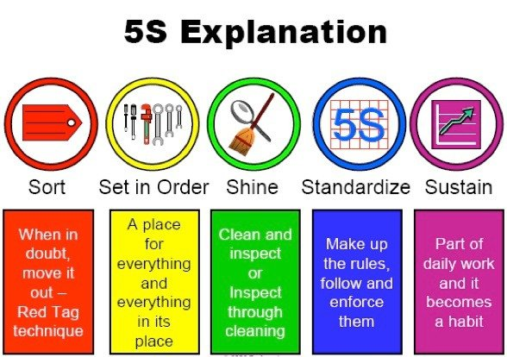**Sustain (Shitsuke)**: To form the habit of always following the first four S’s.

**Process Flow**

**Some General Terms and Explanations:**

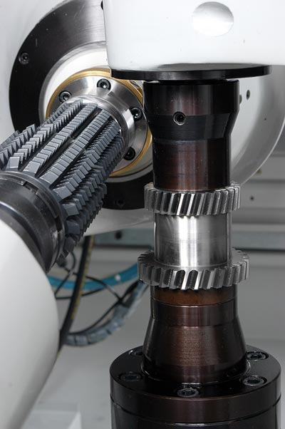There are many technical terms used above a short description of them is given below:

**1. Jigs and Fixtures:**

In simple terms, a jig is a tool that guides the machining tool. A common type of jig is the drill jig, which guides the drill for making holes at desired locations. Using drill jigs increases the production rate drastically. These tools are usually made of metal, such as steel and aluminum, and are generally fitted with positioning devices called bushings. These tools guide the operation of machines and other equipment.

The fixture also reduces the loading, unloading, and fixing the time of the workpiece, which significantly reduces the non-productive hours. Fixtures are used for milling, turning, and grinding operations. To ensure proper alignment and hold of parts, fixtures can include a variety of locating components. Some manufacturers are even turning to 3D printing for their fixtures.

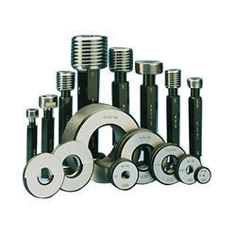**2. Gauges:**

A gauge, in science and engineering, is a device used to make measurements or in order to display certain dimensional information. A wide variety of tools exist which serve such functions, ranging from simple pieces of material against which sizes can be measured to complex pieces of machinery. Depending on usage, a gauge can be described as "a device for measuring a physical quantity", for example "to determine thickness, gap in space, diameter of materials, or pressure of flow", or "a device that displays the measurement of a monitored system by the use of a needle or pointer that moves along a calibrated scale".

**3. Cutting Tools:**

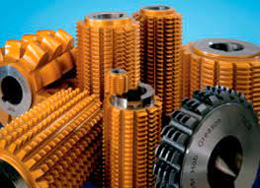Mechanical cutting tools use physical or abrasive force, often applied by hand, to achieve the desired effect. This would include tools such as hacksaws, shears, chisels, or metal grinders. The size of these tools can vary; smaller tools are easier to transport, but larger tools tend to have more cutting capacity. In the context of machining, a cutting tool or cutter is typically a hardened metal tool that is used to cut, shape, and remove material from a workpiece by means of machining tools as well as abrasive tools by way of shear deformation. The majority of these tools are designed exclusively for metals.

**3. Customer Handling Introduction**

* Customer Handling
* Engineering Changes
* Field Failures
* Documentations:
* PPAP
* APQP

**Customer Handling:**

The ability to effectively handle customer complaints and problems is vital for your customer service associates. Though providing outstanding service throughout the selling process is beneficial, customers who do complain and get their problem effectively solved often develop a strong emotional loyalty to a business. Hiring service employees with certain abilities and nurturing them is important to company success.  
  
Nothing gives you a better chance to help a customer than a genuine desire to do so. A helpful attitude means that you instinctively like to assist people dealing with problems or challenges. This desire corresponds neatly with problem-solving abilities and is sought after in the customer service industry.

This skill set encompasses the ability to listen to a customer's problem, identify sources of conflict, come up with alternative solutions and put a remedy into action. Showing customers a willingness to efficiently sort through the mess is valuable.

Accountability is the willingness to take responsibility when you screw up. Some people struggle with taking ownership when "the company" screws up if they weren't personally involved. However, good service employees realize that each business representative must accept the negative experiences of a customer and have a desire to overcome them.

Basic business and service competence combined with strong product knowledge equip service employees to effectively handle problems, explains HelpScout.com. If an employee doesn't understand the nature of the business or the products with which the problem exists, it is more difficult for her to confidently handle complaints.

Product knowledge helps service employees answer questions, identify common errors that arise, troubleshoot and make specific recommendations on how to fix product-related issues. Overall competence in the company environment helps project a more confident image

Two additional, closely related qualities that impact the customer-resolution process are attentiveness and patience. Attentiveness simply means that you are mentally and emotionally present in the midst of handling a customer complaint.

This makes the customer comfortable and prepares you to solve his problem. Patience is necessary to stand in front of someone complaining to you, sometimes in a demonstrative way, while maintaining composure. Patience also protects against getting defensive and going on the attack with a customer.

**Engineering Change Note:**

**Customer Handling**

Whenever there is a change in existing productionized component it is termed as ECN. The customer time to time update the parts for better performance or to remove the problems, in such case the changes done are called Engineering changes. The customer issues a new drawing with the new revision and the changes are marked at respective places. This ECN is needed to be implemented in the part, for this the ECN change request is generated.

As the Gajra receive an ECN, the ECN is noted in the register and the process starts by studying the engineering change. First of all current drawing and new drawing is studied and changes are marked. The changes are then reviewed for any cost impact and whether they are feasible or not mat the current plant facility. If the changes are feasible in current plant facility with no cost impact the changes are implemented.

**Production Part Approval Process (PPAP):**

**Customer Handling**

The Production Part Approval Process (PPAP) handbook is an industry standard that outlines the process to demonstrate engineering design and product specifications are met by the supplier’s manufacturing process. Through PPAP, suppliers and customers agree upon the requirements needed to obtain approval of supplier manufactured parts. Applicable to all parts and commodities, PPAP principles help reduce delays and non-conformances during part approval by providing a consistent approval process.

**What specific challenge(s) does this address?**

* Provides understanding of information required to obtain part approval and standardizes the part approval process
* How to obtain approval of parts/processes after part design changes and/or process changes
* Ensures part submissions are submitted with proper information and enough data to sustain product conformance
* Provides a record of part conformance at launch (allows for measurement of drift from origin)
* Details pertinent design records to ensure traceability of part design status at origin

**What are the benefits of PPAP?**

* Consistent part approval process
* Assurance parts conform to customer requirements
* Evidence of process stability
* Controls product and process change process, providing an approval outlet for all changes to ensure conformance to the next level assembly/process.

**List of documents submitted in PPAP**

* Design Record (Ballooned Drawing)
* Authorized Engineering Change Document (ECN if Any)
* Customer Engineering Approval (if Required)
* Process Flow Chart (PFD)
* Process Failure Mode Effect Analysis (PFMEA)
* Dimensional Result of 100 Jobs (PPAP Lot)
* Material: Dimensional, Test Result Report & Test Certificates
* Process Capability Study Report (SPC)
* Measurement System Analysis (MSA) Study Report
* Qualified Lab Documents
* Control Plan (For Production)
* Part Submission Warrant
* Appearance Approval Report (if Required)
* Master Sample
* Checking Aid List (Gauges)
* Packing Standard
* List of Special Characteristics
* Pre Delivery Inspection (PDI)

**Advance Product Quality Process (APQP):**

**Customer Handling**

Advanced product quality planning (APQP) is a framework of procedures and techniques used to develop products in industry, particularly in the automotive industry. It differs from Design for Six Sigma in that the goal of DFSS is to reduce variation. Advanced Product Quality Planning, which stands for APQP—is a structured process employed when introducing a new product in the market or incorporating changes in the product after its release. This method ensures that there is proper documentation of the processes involved when manufacturing new products and helps detect defects during production. A Cross-Functional Team (CFT) composed of engineering, manufacturing, and quality, procurement, and distribution professionals performs an APQP to ensure that products meet or even exceed customer requirements. Primarily practiced in the automotive industry, it has been adopted by other manufacturing sectors such as aerospace, defense, medical, and pharmaceutical since this method is proven effective.

**List of documents submitted in APQP**

* Product Quality Planning Checklist
* Product requirement Letter from (Export/ Sales O.E./Marketing (Replacement) Deptt.)
* Product Quality Timing Plan
* Product Drawing Original (Ballooned)
* Product Drawing GGL make (if applicable)
* Process Layouts and P.A.S. copies/Print
* Checking Aid List (Gauges)
* Risk Assessment Sheet
* Characteristics Matrix
* SPL. Characteristics Product and Process
* Team Feasibility Commitment Report
* Sample Approval/ Fitment Trail Report.
* Packaging Specification
* Process flow Chart (Routine Sheet)
* Floor Plan Layout(PFD)
* Control Plan
* MSA Plan
* Pre. Process Capability Study Plan
* Quality Planning Sign off & Management Support

**4.** **Audits**

* The Audit
* Types of Audits
* IATF
* OHSAS
* Customer Audits
* How Audits are done.

**The Audits:**

Audit is the examination or inspection of various books of accounts by an auditor followed by physical checking of inventory to make sure that all departments are following documented system of recording transactions. It is done to ascertain the accuracy of financial statements provided by the organization. The purpose of an audit is to form a view on whether the information presented in the financial report, taken as a whole, reflects the financial position of the organization at a given date.

**Types of Audits:**

There are mainly 3 types of audits held in an organization they are:

* Internal Audits
* External Audits
* Government or IRS audits

Internal auditing is an independent, objective assurance and consulting activity designed to add value and improve an organization’s operations. It helps an organization accomplish its objectives by bringing a systematic, disciplined approach to evaluate and improve the effectiveness of risk management, control, and governance processes.

Performed by professionals with an in-depth understanding of the business culture, systems, and processes, the internal audit activity provides assurance that internal controls in place are adequate to mitigate the risks, governance processes are effective and efficient, and organizational goals and objectives are met.

An external auditor performs an audit, in accordance with specific laws or rules, of the financial statements of a company, government entity, other legal entity, or organization, and is independent of the entity being audited.

Government audit means the organized and independent examination of a public entity's financial, administrative and other operations for evaluating and verifying them.

At Gajra Internal audits are held every month and external agencies such as Bureau Veritas (BV) use to audits every year. Government organization regularly audits for Environmental health and safety, and general audits.

**Audits**

**International Automotive Task Force (IATF):**

The IATF is an “ad hoc” group of automotive manufacturers and their respective National Automotive Industry Associations, formed to provide improved quality products to automotive customers worldwide. Specifically, the purposes for which the IATF was established are:

1. To develop a consensus regarding international fundamental quality system requirements, primarily for the participating companies’ direct suppliers of production materials, product or service parts or finishing services (e.g. heat treating, painting and plating). These requirements will also be available for other interested parties in the automotive industry.
2. To develop policies and procedures for the common IATF third party registration scheme to ensure consistency worldwide.
3. To provide appropriate training to support IATF 16949 requirements and the IATF registration scheme.
4. To establish formal liaisons with appropriate bodies to support IATF objectives.

IATF members include the following vehicle manufacturers: BMW Group, Ford Motor Company, Geely Group, General Motors, IVECO Group, Jaguar Land Rover (JLR) Limited, Mercedes-Benz Group AG, Renault Group, Stellantis (ex FCA), Stellantis (ex PSA), Volkswagen AG and their respective National Automotive Industry Associations – AIAG (U.S.), ANFIA (Italy), FIEV (France), SMMT (U.K.) and VDA (Germany).

IATF 16949 is a global Quality Management System Standard for the automotive industry. IATF 16949:2016 incorporates the structure and requirements of the ISO 9001:2015 quality management system standard with additional automotive customer-specific requirements. It was developed by the International Automotive Task Force (IATF), with support from AIAG. This standard requires certification by a 3rd party auditor (Registrar/CB/Certification Body). Here are some key areas of focus:

* Continuous improvement
* Defect prevention
* Reducing waste
* Product safety
* Risk management
* Contingency planning
* Requirements for embedded software
* Change and warranty management
* Management of sub-tier suppliers

**Differences between ISO 9001 and IATF 16949:**

**Audits**

The most fundamental difference between ISO 9001 and IATF 16949 involves the entities responsible for the standards. ISO 9001 is managed by the International Organization for Standardization, while IATF 16949 was devised by the IATF with significant input from automotive industry members, including automakers and groups like the Automotive Industry Action Group.

Furthermore, ISO 9001 centers on customer satisfaction, but IATF 16949 goes further, necessitating compliance with company-specific requirements outlined in the standard. Additionally, ISO 9001 can apply to any location operated by an organization, while IATF 16949 focuses only on sites that develop, produce or service OEM auto parts — not aftermarket parts.

In understanding the differences between the standards, it's essential to look at a side-by-side comparison of the requirements for ISO 9001:2015 vs. IATF 16949. Again, while some people request an ISO 9001 vs. TS 16949 comparison, it's important to remember that the current standard is IATF 16949.

**Audits**

**Occupational Health and Safety Assessment Series (OHSAS):**

OHSAS 18001, Occupational Health and Safety Assessment Series, was an international standard for occupational health and safety management systems that was subsequently adopted as a British Standard. Compliance with it enabled organizations to demonstrate that they had a system in place for occupational health and safety. BSI cancelled OHSAS 18001 to adopt ISO 45001. ISO 45001 was published in March 2018 by the International Organization for Standardization.[1] Organizations that are certified to OHSAS 18001 were able to migrate to ISO 45001 by March 2021 to retain a recognized certification

Recognizing this deficit, an international collaboration called the Occupational Health and Safety Assessment Series (OHSAS) Project Group was formed to create a single unified approach. The Group comprised representatives from national standards bodies, academic bodies, accreditation bodies, certification bodies and occupational safety and health institutions, with the UK’s national standards body, BSI Group, providing the secretariat.[4] Drawing on the best of existing standards and schemes, the OHSAS Project Group published the OHSAS 18000 Series in 1999. The Series consisted of two specifications: 18001 provided requirements for an OHS management system and 18002 gave implementation guidelines.

**Customer Audits:**

**Audits**

Customer service audits uncover what your company and employees are doing well and help identify areas of opportunity to improve the customer service experience. A third-party audit provides an unbiased experience that may not be the same as what happen “when the bosses are watching.”

Customer audits are the essential part of the business as the customer come to know how we are producing the product. The customer has the right to ask that how we are producing the product. Weather we are producing the product with right mean without causing any unnecessary resource wastage. This also helps to build the good relation and trust on the supplier. Many time an new ideas also comes by interacting with the customers.

**How Audits are done:**

Audits is a systematic approach for checking the process of the things done. The whole process is a system generated i.e. everything is defines as per the clauses defined in the audit manual. First of all an opening meeting is done and the audit process starts. This ends at the closing meeting where all the relative points are discussed.

The process starts from scheduling the audit date, the auditor visits the facility and thoroughly examines the records. He use to randomly select a part and ask about the complete history of the part. If the documents are not presented or are mismatching then the auditor charges N.C. (Non-Conformity). If the N.C. are not observed then the auditor also gives the observation points i.e. the areas where there is possibility of improvement.

This non conformity is recorded and officially said to the M.R. for clearing the N.C. before the datum date. The M.R. is now responsible for closing the N.C. On successful completion of the audit the Audit Body releases a certificate to the organization valid till next audit.

This certification plays a vast role in influencing the customers since it is the proof of quality and systematic approach. Many a time the customers ask for the certifications before signing the business deals.

**.**

**5. Conclusion**

**The Conclusion to Company:**

Gajra gear is a well-known gear manufacturing company. It is big brand in field of gear manufacturing. It has a great influence on the customer. The quality of gears manufactured is a milestone in the field. What drives this growth at Gajra is commitment to top quality by following good manufacturing. The company has adapted many technical techniques and system to optimize the productions. The infrastructure of the company is old but yet suitable to deliver the sustainable quality product.

The company provide a good working environment to its employee’s with a good work life balance. The engineer’s at Gajra are also highly skilled persons. They are all capable to handle the toughest situations with scientifically solving the problems.

The Gajra since an old company somehow lags in digitization, there is a big possibility of the development in the field of digitization although some places digitization process is implementing. The company need to improve the capacity as the orders are more and capacity is less.